**March 25, 2020**



**Virtual Immersion Day**

Serverless Data Lake with AWS

# Table of Contents

Table of Contents 2

Overview 3

Lab Solution Architecture 3

Lab Pre-Requisites 4

Section I - Data Ingestion & Storage Layers 4

Lab 1.1 - Create simulated data in real-time data with KDG 4

Lab 1.2 - Create Kinesis Firehose Delivery Stream to load Stream data on S3 9

Summary & Next Steps 16

References 16

# Overview

A **data lake** is a centralized repository for both structured and unstructured data where you store data as-is, in open-source file formats to enable direct analytics. Implementing a Data Lake architecture requires a broad set of tools and technologies to serve an increasingly diverse set of applications and use cases. Refer to <https://aws.amazon.com/tr/big-data/datalakes-and-analytics/what-is-a-data-lake/>

**Lambda architecture** (should not be confused with the AWS Lambda compute service.) is a data-processing design pattern to handle massive quantities of data and integrate batch and real-time processing within a single framework. Various AWS services are used as building blocks of this unified architectural pattern that unifies stream (real-time) and batch processing. In this lab, you will focus on the batch processing layer. Refer to whitepaper “Lambda Architecture for Batch and Stream Processing (October 2018)” <https://d0.awsstatic.com/whitepapers/lambda-architecure-on-for-batch-aws.pdf>

# Lab Solution Architecture



Figure 1: Serverless Data Lake Lab Solution Architecture

This lab guide is prepared to assist you ingest, store, transform, create insights on unstructured data using AWS serverless services. Most of the demos make use of AWS Console, however all the labs can be automated via Cloudformation templates, AWS CLI or AWS API.

# Lab Pre-Requisites

In order to complete this immersion day lab, please follow the preparation steps outlined within the Lab Preparation Guide (provided withint the ‘Files’ section of the adobe connect meeting).

# Section I - Data Ingestion & Storage Layers

# Lab 1.1 - Create simulated data in real-time data with KDG

In lab 1, you will deploy an open-source serverless real-time data generator tool to simulate data in real-time and ingest into AWS Kinesis Firehose. We will simulate product catalogue data with random values. The data will be used in upcoming labs to demonstrate storage, processing, reporting and visualization.

The tool is called Kinesis Data Generator (KDG), and is available on GitHub under: <https://github.com/awslabs/amazon-kinesis-data-generator>

KDG is a UI that simplifies how you send test data to Amazon Kinesis Streams or Amazon Kinesis Firehose. Using the Amazon Kinesis Data Generator, you can create templates for your data, create random values to use for your data, and save the templates for future use.

1. If you have performed the pre-requisites already, please proceed further with the steps outlined below. İf not, please follow the lab preparation document to perform the pre-req’s before proceeding further:
   1. Within the CloudFormation console, locate the stack named ‘Kinesis-Data-Generator-Cognito-User’ and Select the Outputs tab of the CloudFormation Stack, which contains a URL generated for your KDG (as shown below)

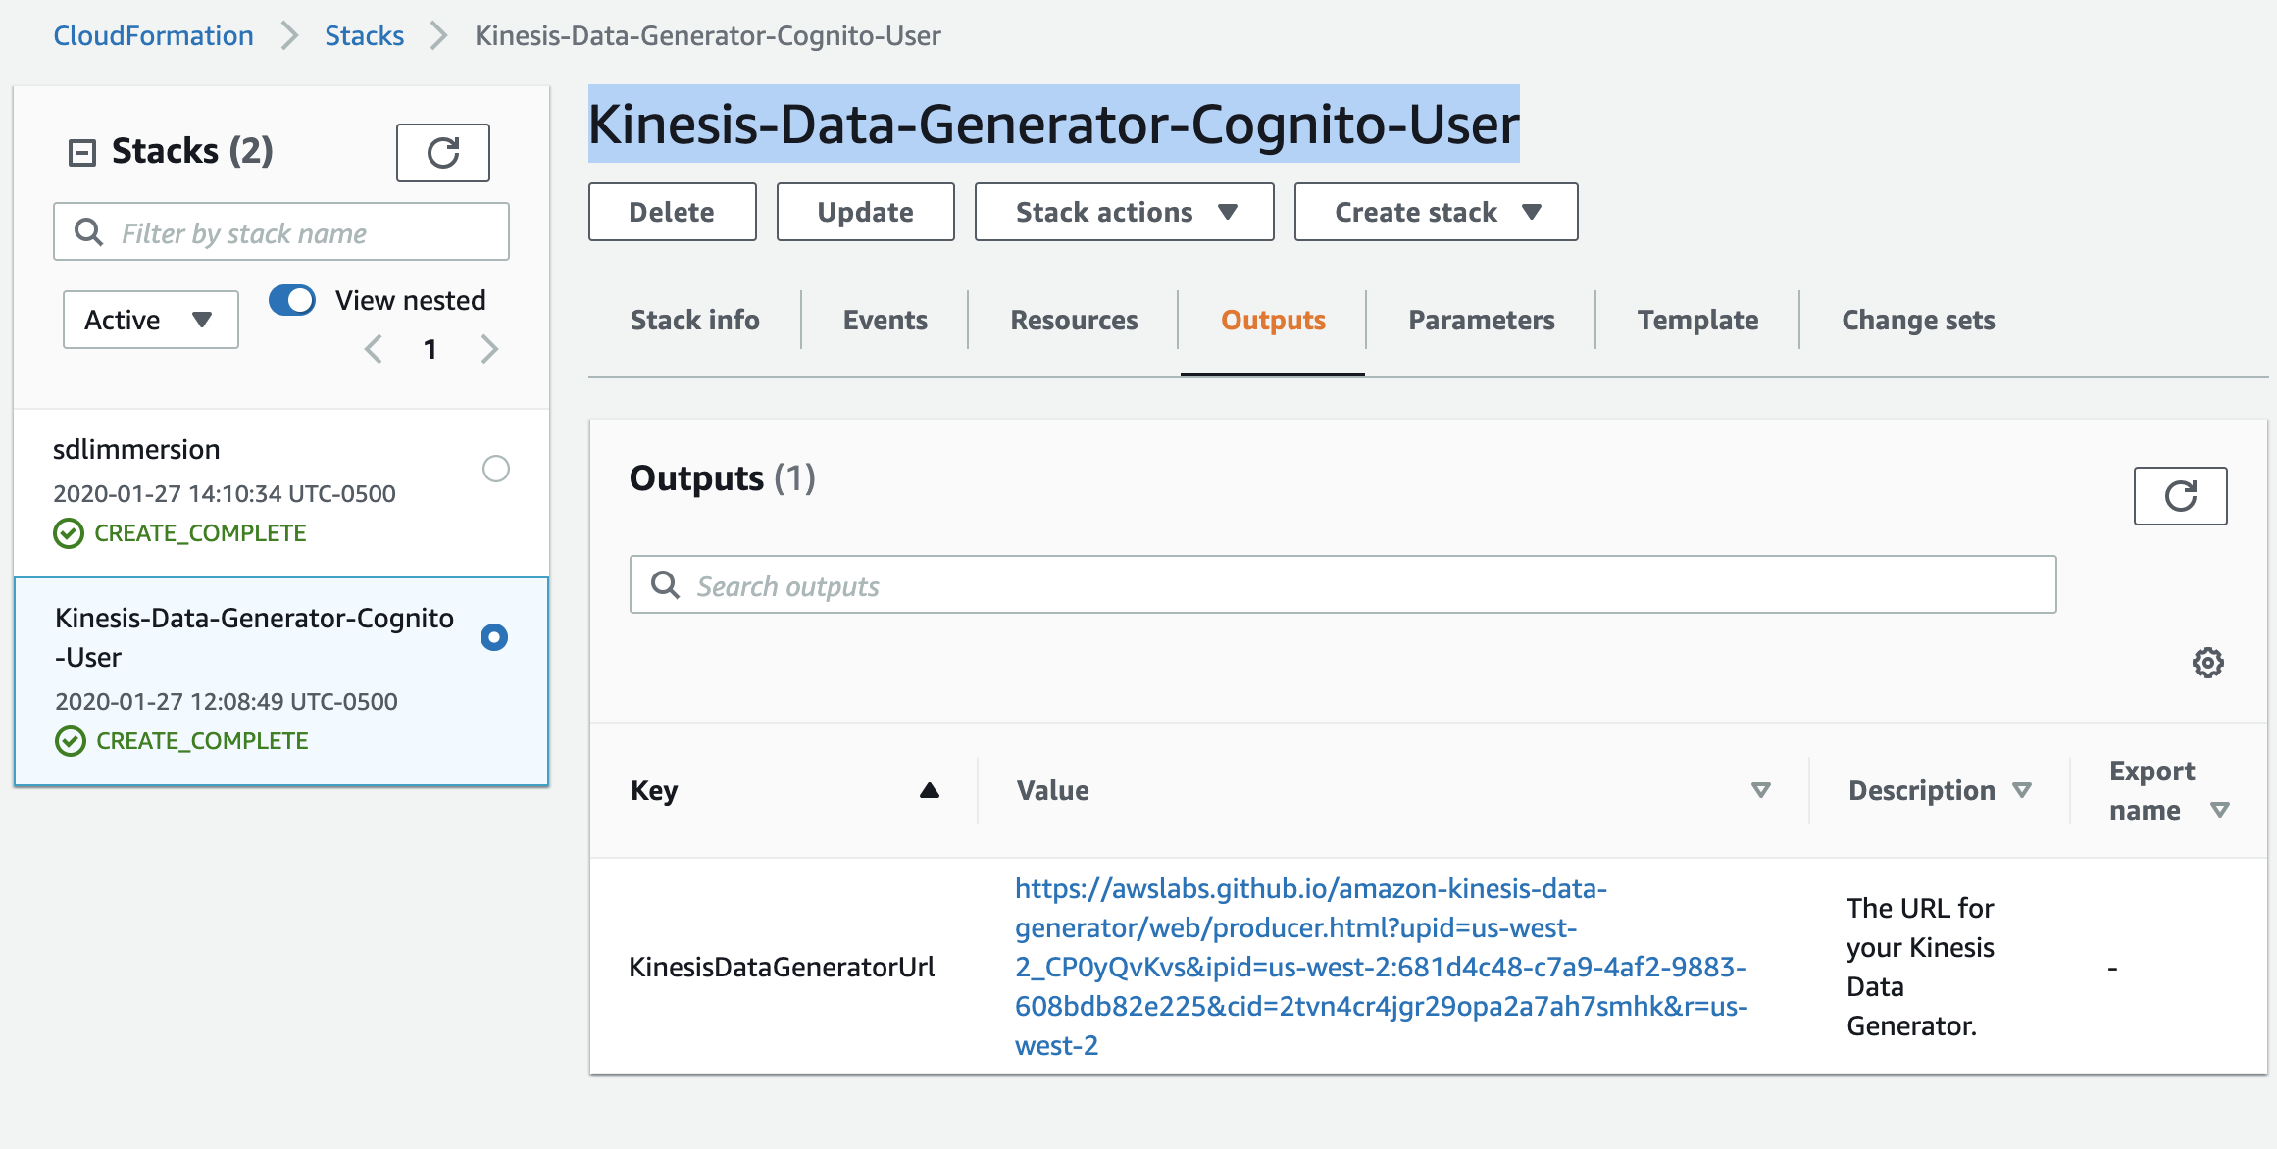

* 1. Copy the URL to your browser and login with the user/password you created during CloudFormation stack creation.

1. Login to KDG using your credentials.

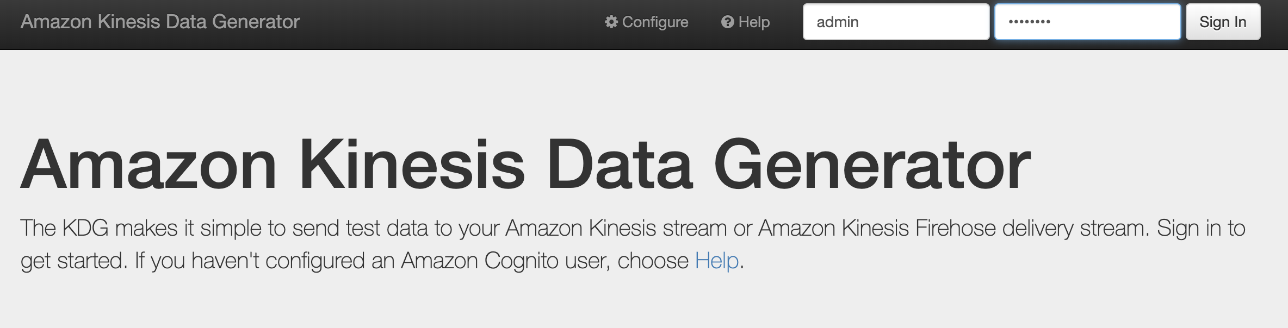

1. At this stage, there’s no stream we can push data towards. Let’s define the structure of our simulated data using the parametrized template. Copy and paste it to the template tabs. Template to use:

|  |
| --- |
| {  "productName" : "{{commerce.productName}}",  "color" : "{{commerce.color}}",  "department" : "{{commerce.department}}",  "product" : "{{commerce.product}}",  "imageUrl": "{{image.imageUrl}}",  "dateSoldSince": "{{date.past}}",  "dateSoldUntil": "{{date.future}}",  "price": {{random.number(  {  "min":10,  "max":150  }  )}},  "campaign": "{{random.arrayElement(  ["BlackFriday","10Percent","NONE"]  )}}"  } |

This template generates data such as (each record will be random).

|  |
| --- |
| {  "productName" : "Generic Granite Ball",  "color" : "teal",  "department" : "Beauty",  "product" : "Cheese",  "imageUrl": "http://lorempixel.com/640/480",  "dateSoldSince": "Mon Dec 04 2017 19:19:50 GMT+0300 (GMT+03:00)",  "dateSoldUntil": "Fri May 17 2019 08:56:56 GMT+0300 (GMT+03:00)",  "price": 64,  "campaign": "10Percent"  } |

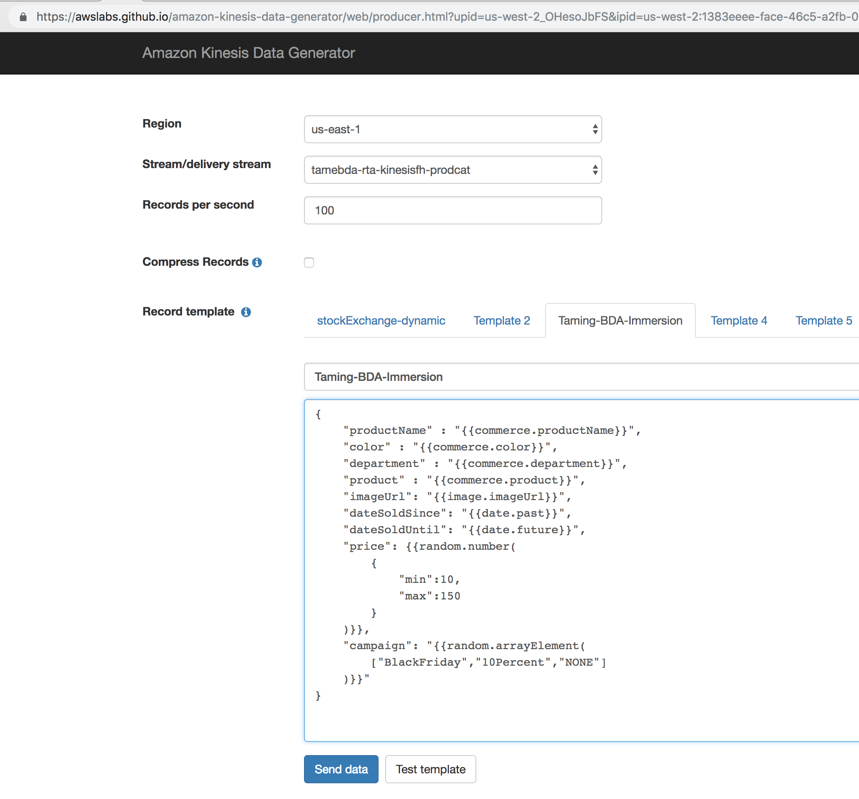

Hint: KDG makes use of an open-source toolkit called Faker.js (available in GitHub: <https://github.com/marak/Faker.js/> ). You can customize the template as you wish. Check Faker.js documentation for details.

1. Press Test Template to generate a few records.

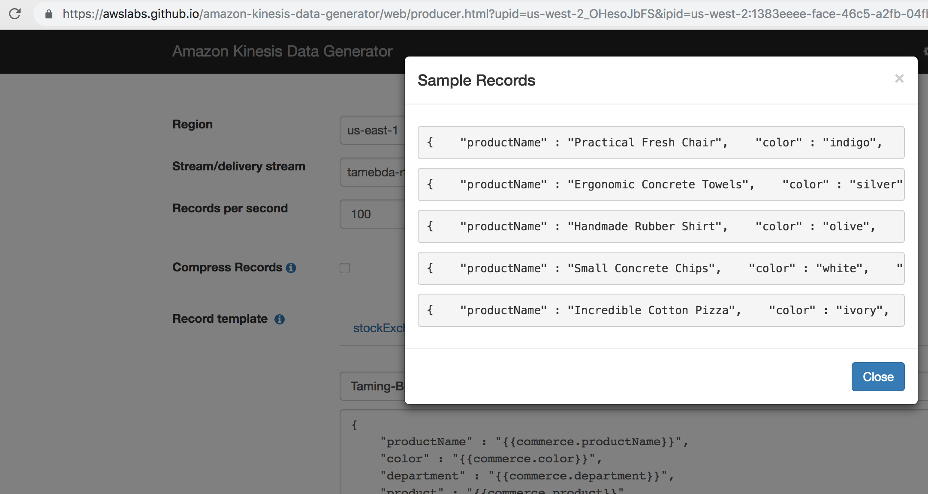

You have successfully created KDG, and are ready to ingest data to the AWS Kinesis Firehose. Please proceed to the next lab.

# Lab 1.2 - Create Kinesis Firehose Delivery Stream to load Stream data on S3

In this lab, you will create a Firehose delivery stream from the AWS Management Console, configure it with a few clicks to store incoming stream data into S3, and start sending data to the stream Kinesis Data Generator (created in Lab 1) as data source.

**Amazon Kinesis Firehose** is a serverless service used to reliably load streaming data into data stores and analytics tools. It can capture, transform, and load streaming data into Amazon S3, Amazon Redshift, Amazon Elasticsearch Service, and 3rd Party services (e.g. Splunk), enabling near real-time analytics.

Amazon Kinesis Firehose benefits are:

* No explicit provisioning or scaling,
* Extremely simple APIs and console,
* Guaranteed data capture and reliable delivery.
* It is a fully managed service that automatically scales to match the throughput of your data and requires no ongoing administration.
* It can also batch, compress, transform, and encrypt the data before loading it, minimizing the amount of storage used at the destination and increasing security.

1. Create a bucket with exactly the naming convention mentioned below and press Create. Bucket name: (name: **<your initials>-tame-bda-immersion**. For instance **fs-tame-bda-immersion** for Frank Sinatra) (Important, the CloudFormation template creates IAM policies according to a naming convention for simplicity. Therefore, please use the exact naming convention).

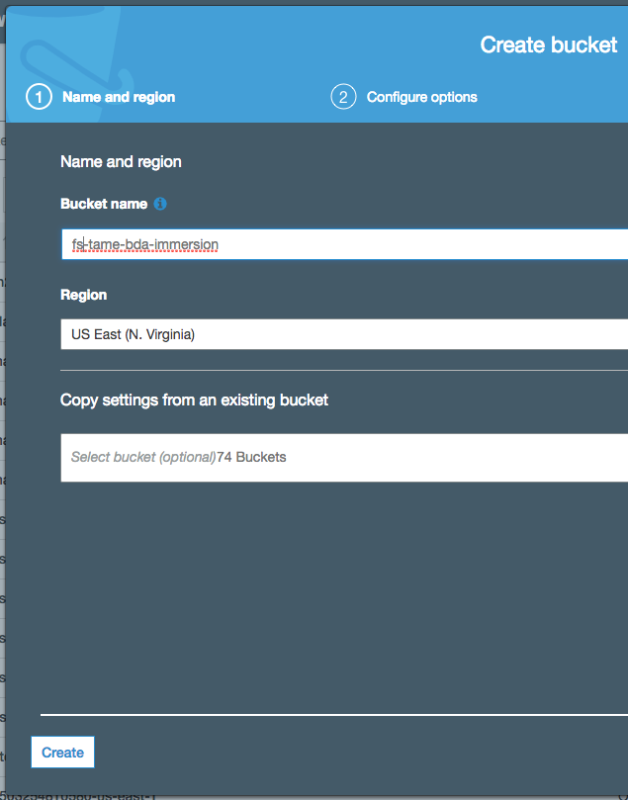

1. Create a Firehose delivery stream by chosing the Kinesis service from the AWS console and then selecting ‘Create delivery stream’ under Kinesis Firehose delivery streams to configure the following:
   1. Stream name: **tamebda-rta-kinesisfh-prodcat**
   2. Source: **direct put**
   3. Transformation: **disabled**
   4. Conversion: **disabled**
   5. Destination: S3
      1. (name: <your initials>**-tame-bda-immersion. For instance hba-tame-bda-immersion**)
      2. prefix: **raw/ (Important: Don’t forget the trailing “/” character. It shall be raw/ and not raw)**
   6. buffer: 1 **MB, 60 seconds**
   7. compression: **gzip**

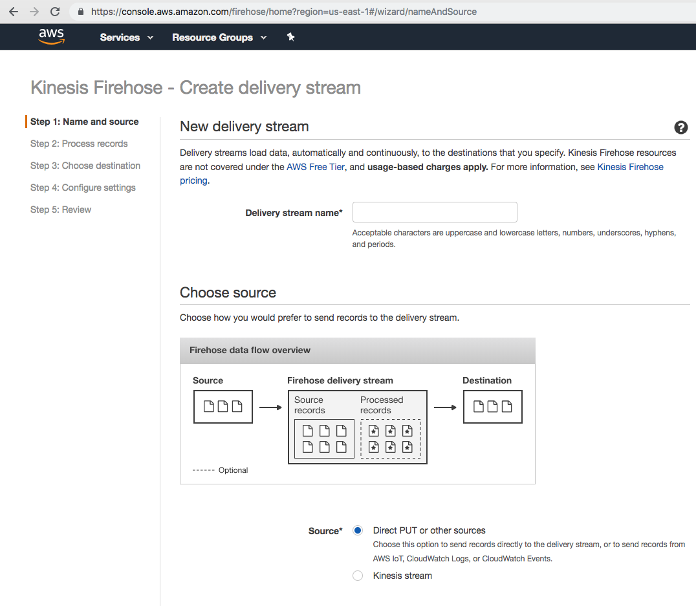

* 1. IAM:
     1. IAM role: Select the role created by the CloudFormation template (AWS Console -> CloudFormation -> Stacks -> sldimmersion-> Outputs. The IAM role has a name like “ **sdlimmersion-tameFHoseRoleSlessDataLakeImmersion-<UNIQUE ID>**

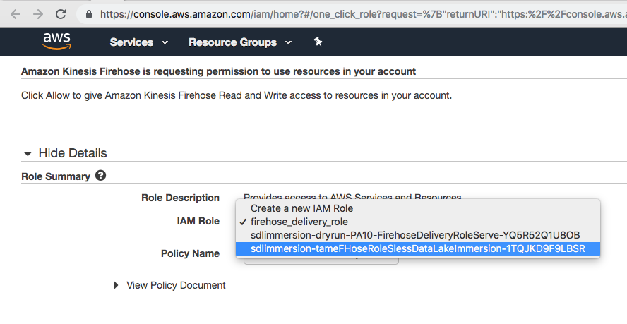

* + 1. Policy: Select the role created by the CloudFormation template. The IAM policy has a name like: “**tameFHosePolicySlessDataLakeImmersion**”

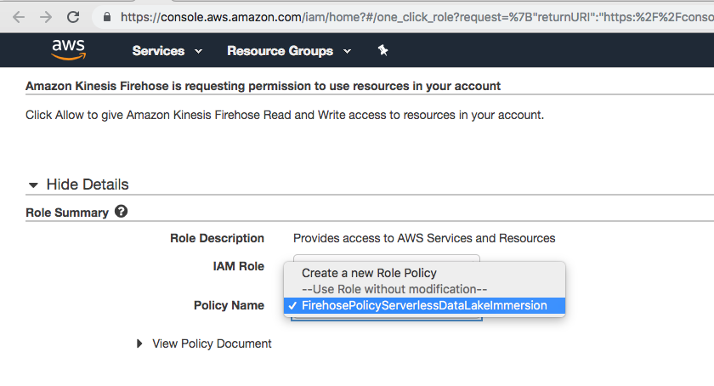

1. Return to Kinesis Data Generator tool, select the region you created Firehose Delivery stream (us-east-1), and select your stream. Start sending simulated data at 1000 messages per second rate (If the delivery stream doesn’t appear in KDG, simply logout and login to the KDG to refresh).

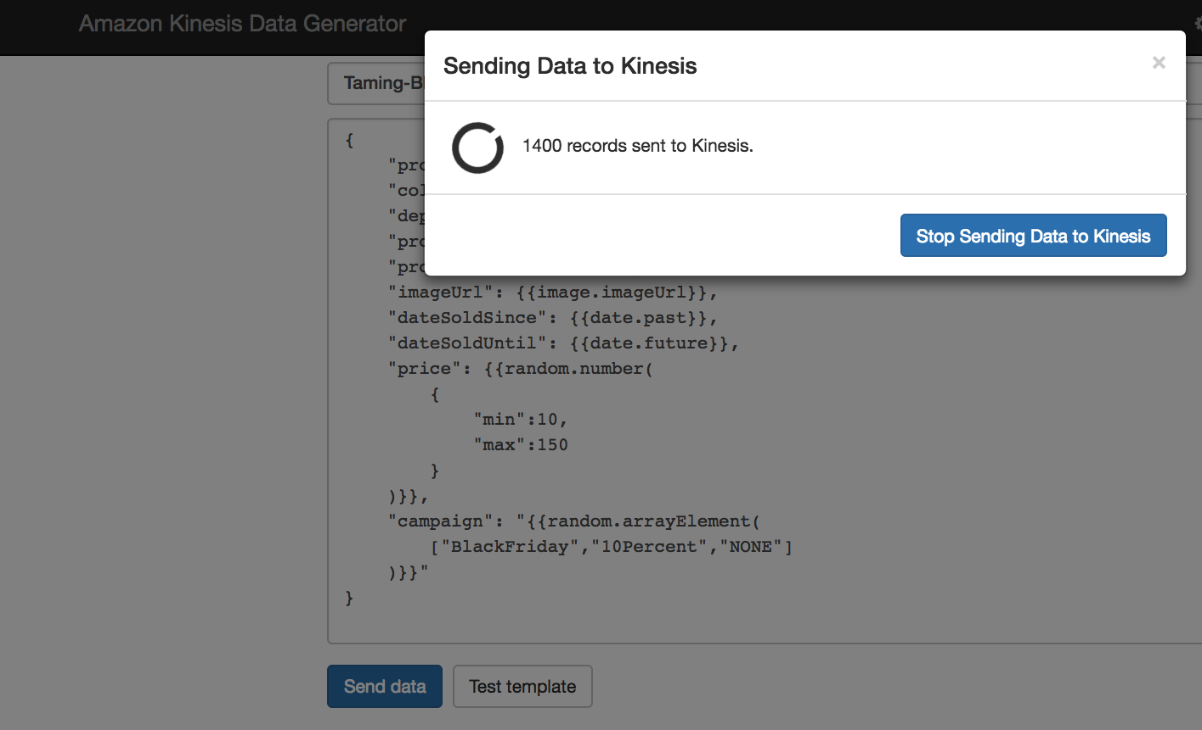

1. Wait a few minutes. From within the AWS Console -> Firehose -> Monitoring tab, check the activity on your delivery stream.

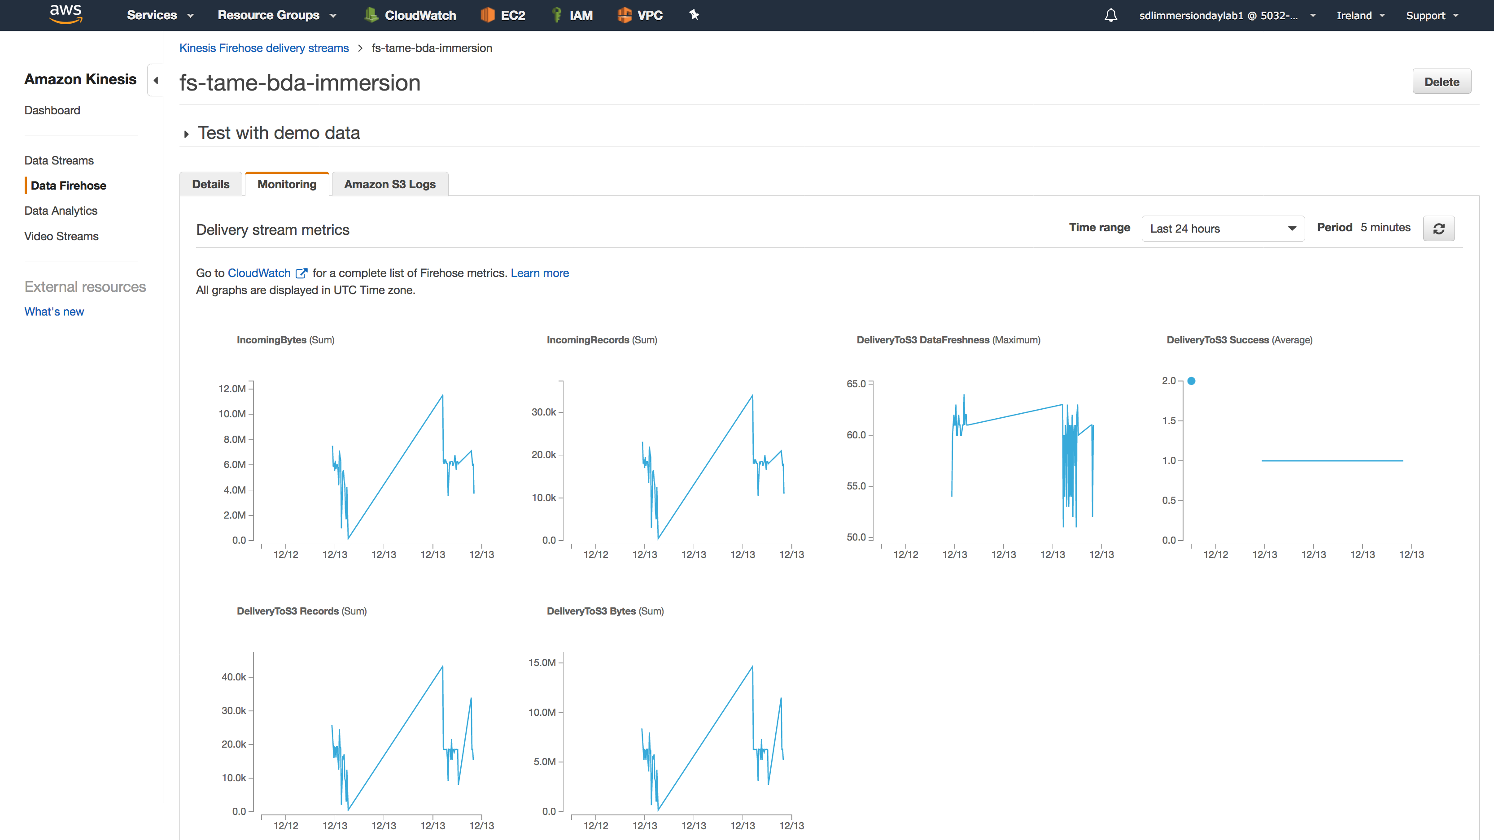

1. From AWS console -> S3, go to the S3 folder you created. You should see data in s3://<bucket-name>/<prefix>/<year>/<month>/<day>/<hour> format. For instance: **s3:// <your initials>-tame-bda-immersion/raw/2018/11/14/12**.
   1. Hour is in UTC format.
   2. Depending on your buffering configuration, Firehose writes data to S3 either when size limit (1 MB in our case) or time limit (60 seconds in our case) is reached, whichever condition is satisfied first triggers data delivery to Amazon S3.
2. **Hint:** Don’t stop sending events from KDG. Let it run while you are working on the other labs. Since the KDG is serverless, there are no servers to pay when there is no traffic. Kinesis Firehose is charged per GB, and during the whole day, the scenario above will not ingest data more than a few hundred MBs.

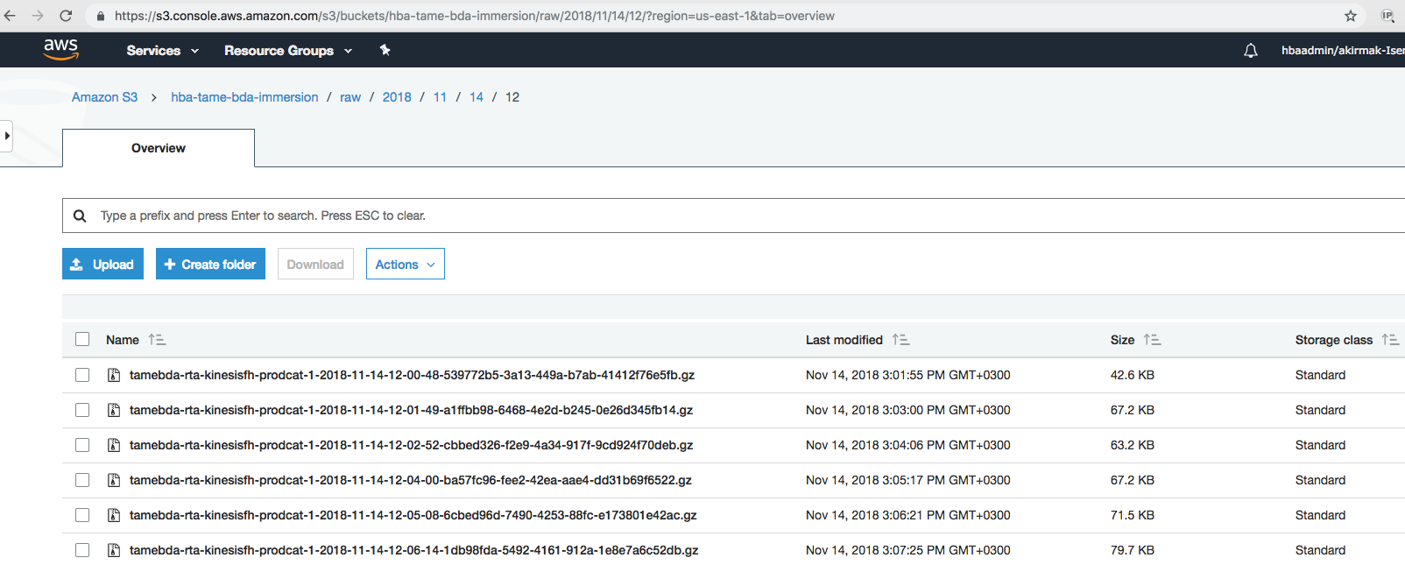

# Summary & Next Steps

Congratulations. You have successfully created an ingestion pipeline without servers, which is ready to process huge amounts of data.

So, what’s next? In the next lab, you will create the processing pipeline to convert, transform the data from the ingestion layer..

# References

1. Website, AWS Data Lake, <https://aws.amazon.com/tr/big-data/datalakes-and-analytics/what-is-a-data-lake/>
2. Whitepaper, “Lambda Architecture for Batch and Stream Processing, AWS, October 2018, <https://d0.awsstatic.com/whitepapers/lambda-architecure-on-for-batch-aws.pdf>